Murray Edwards College
Application For Blues Funding Award
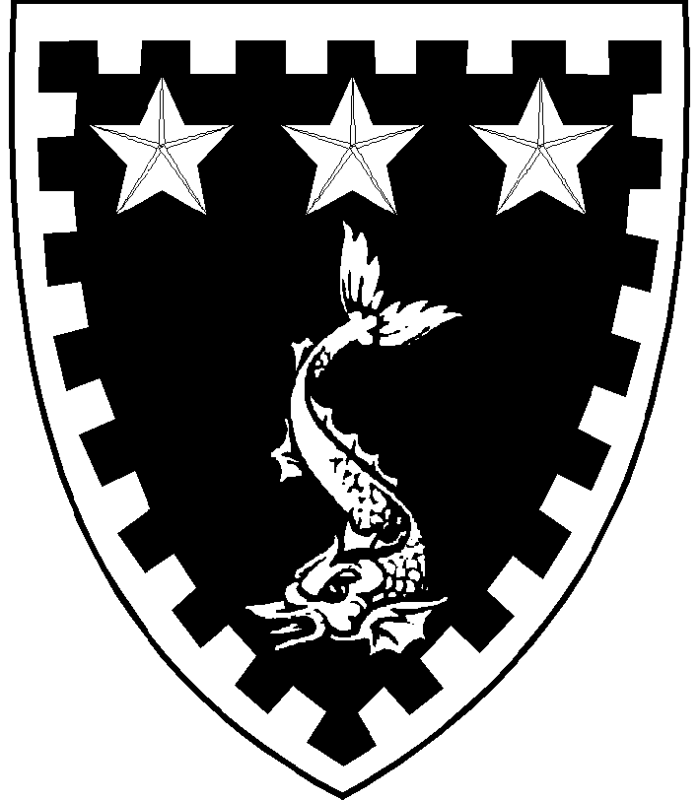
The Rosemary Murray Fund offers one annual award for participation in one University sport. If no Blue has been attained at time of application, £75 is available towards training costs; any student who has achieved a Half Blue will receive £150, and any student who has received a Full Blue will receive £200. You may apply for the remainder of the award should you be successful in achieving a Full or Half Blue and you have already been awarded a training award in any one year.
Please ask your coach or squad leader to sign the form, confirming attendance at training. Please also discuss your application with your Tutor / Grad Tutor who must sign the form before it is submitted.

Full Name: |  |  |  |  |  |  |  | Tutor:
Study Yr: |  |  | Subject: |  |  |  | Student Email:
Sport (one only)
Please indicate your status at the time of application by checking one of the following:
Training towards Blue/Half Blue (£75) |  |  |  |  |  | ☐ |  |  |  | Comments:
I have been awarded a Half Blue in this academic year (£150) |  |  |  |  |  | ☐
I have been awarded a Full Blue in this academic year (£200) |  |  |  |  |  | ☐
Claim for remainder of award after attainment |  |  |  |  |  | ☐ |  |  |  | (£75 for Half Blue; £125 for Full; or £50 going from half to full blue)

Please detail the time commitment of your training and the costs involved. Once you have completed this section, please ask you coach or team leader to sign this section
 | Coach’s Signature |  | Date
Tutor’s comments
 | Tutor’s signature: |  | Date
 | Student's signature: |  |  | Date

By the end of the academic year of the award, please provide the Tutorial Office with a photograph of you engaged in your sport, so that we can properly celebrate your achievements.

